**AWS Setup**

Launch a AWS EC2 instance:

Instance Name : Project-app

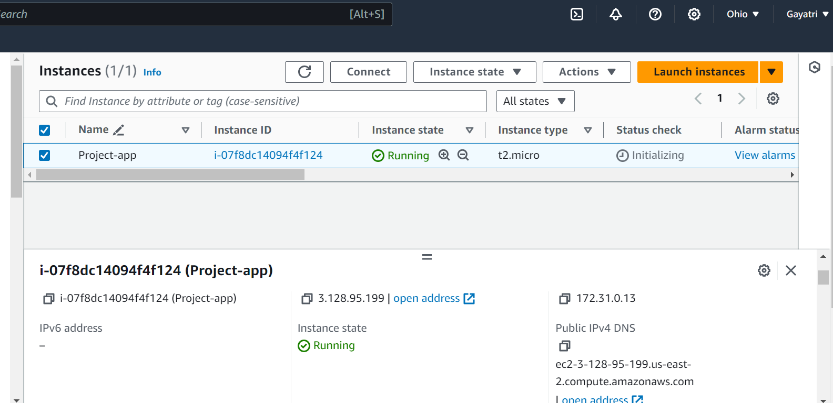

Security group:

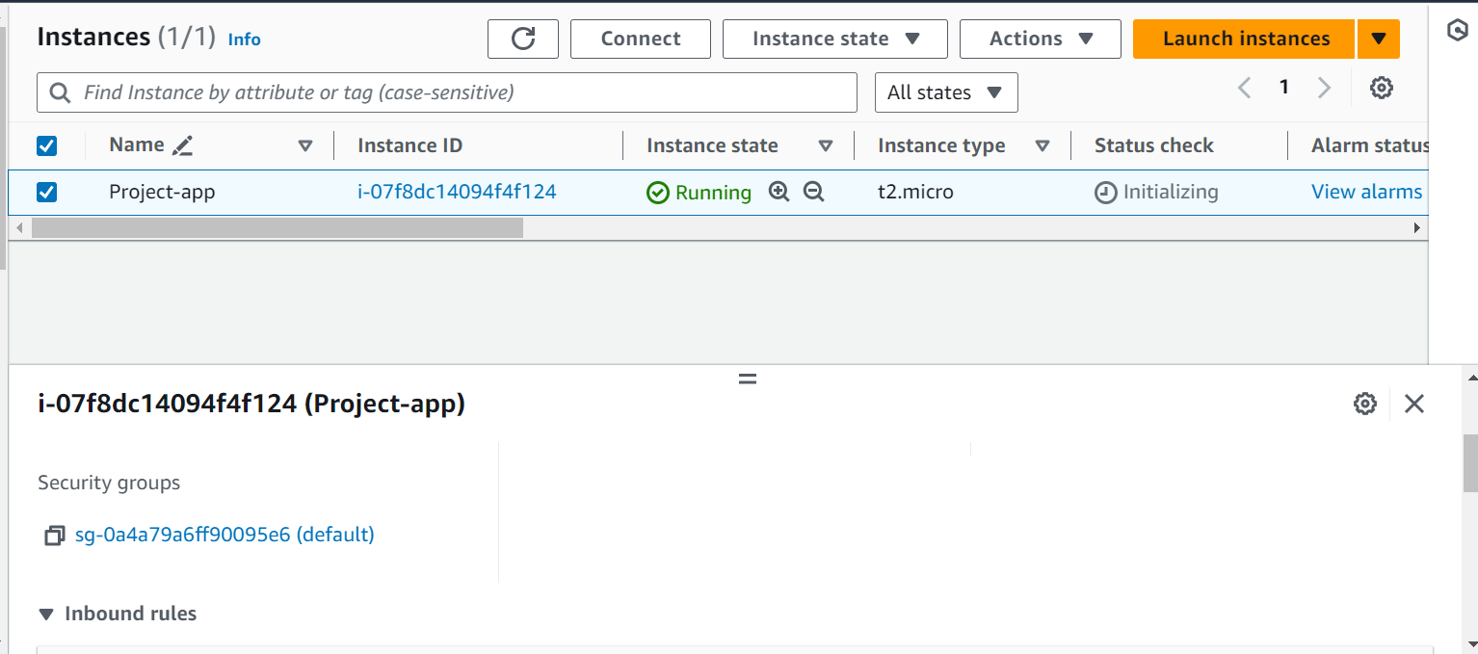

Inbound Rules:

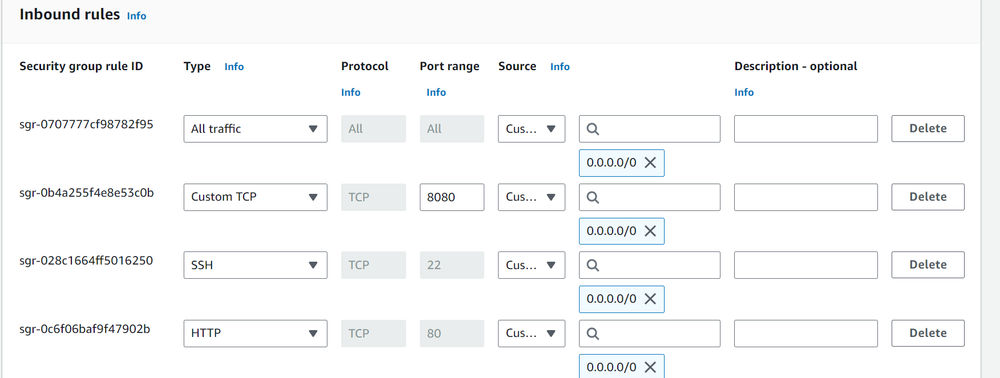

Outbound Rules:

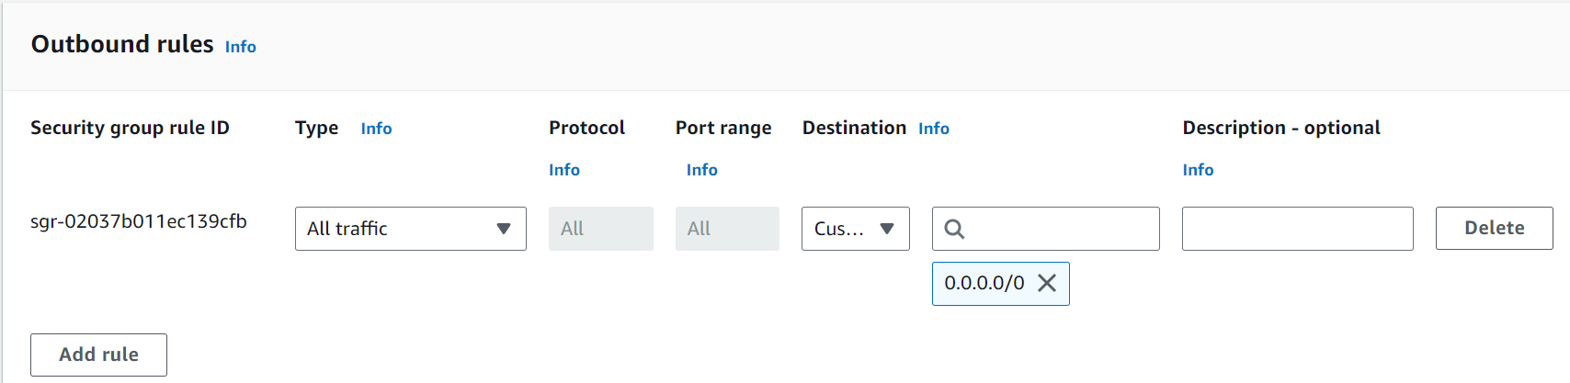

**GitHub**

Created a repo called devops-build in git

GitHub Repo url : <https://github.com/NambariGayatri/devops-build.git>

Main Branch:

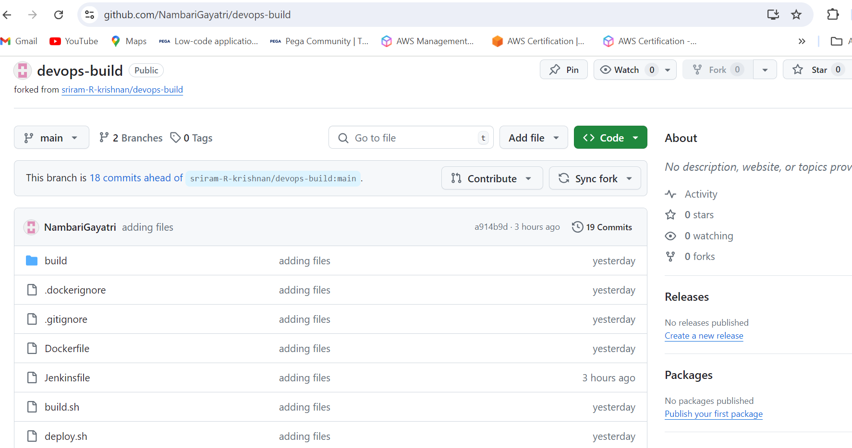

Dev branch:

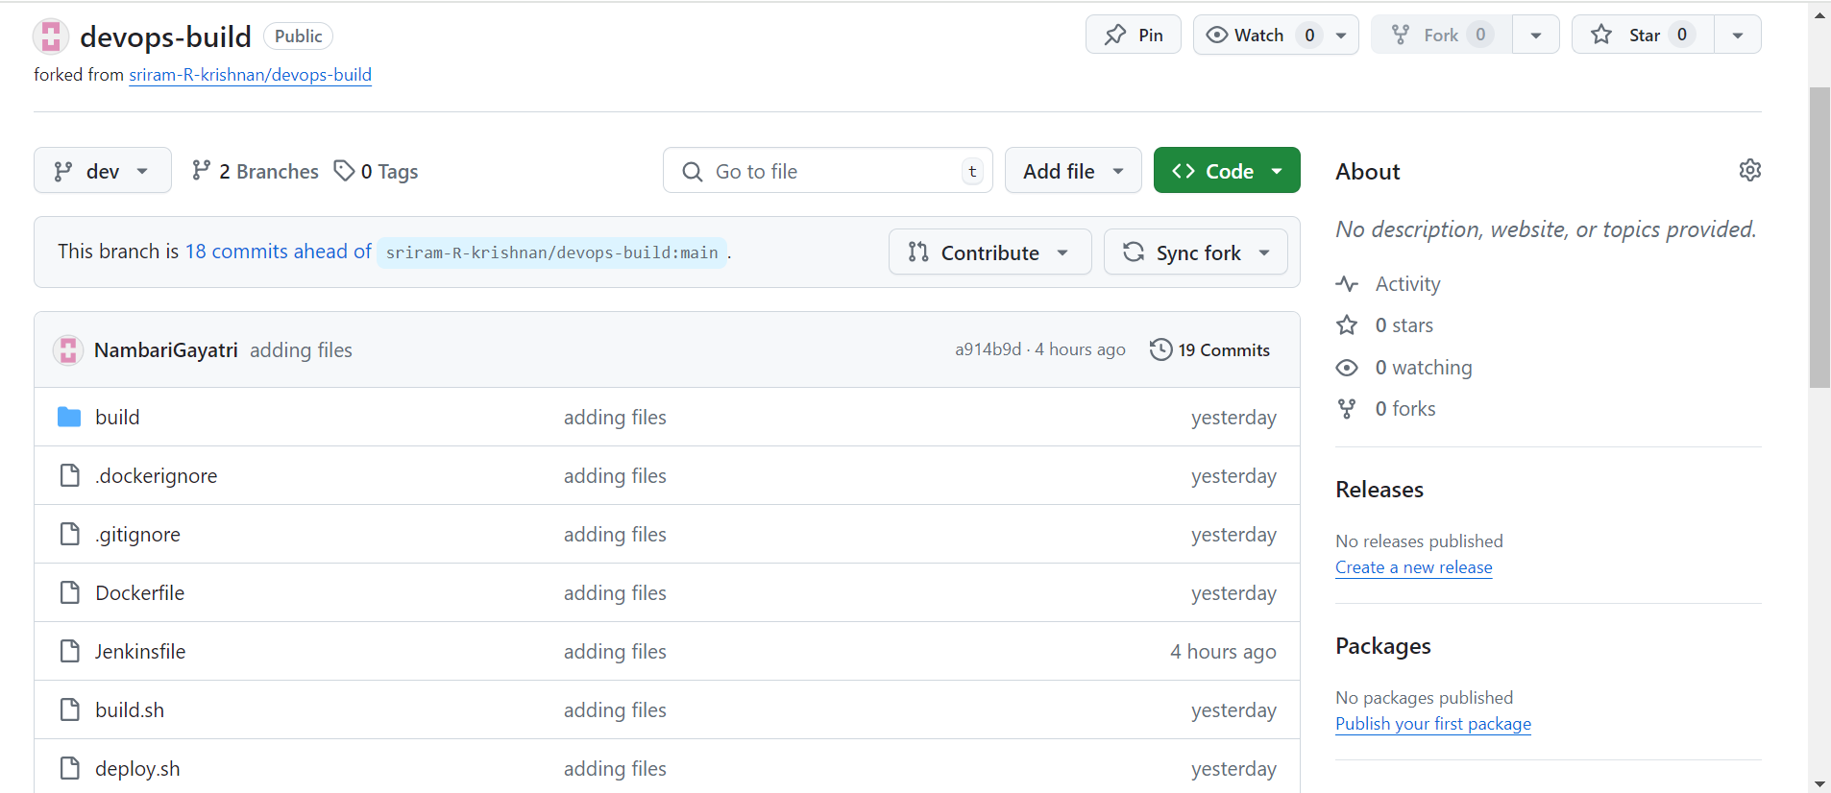

Jenkins login page:

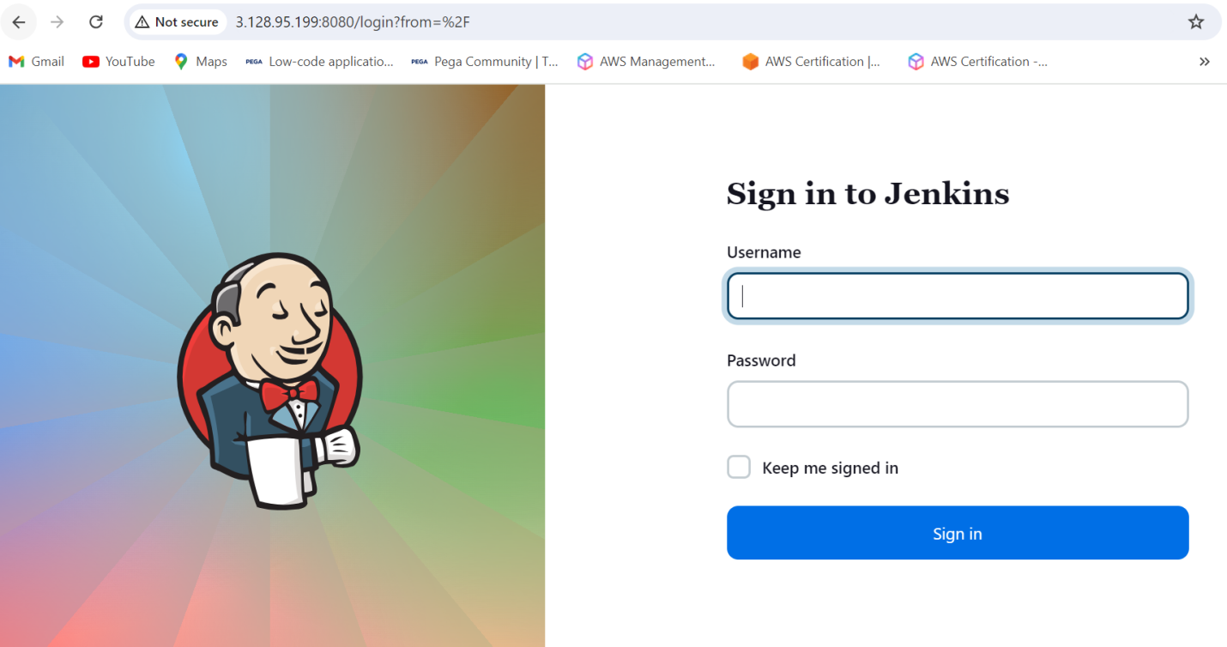

Configuration settings:

Docker Plugin config:

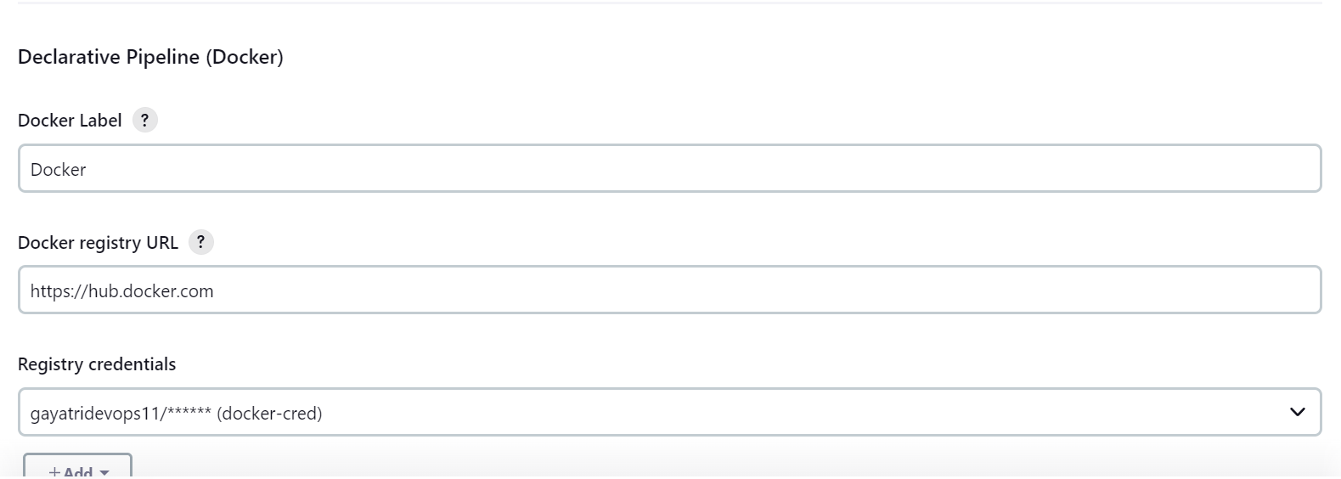

Pipeline Git config:

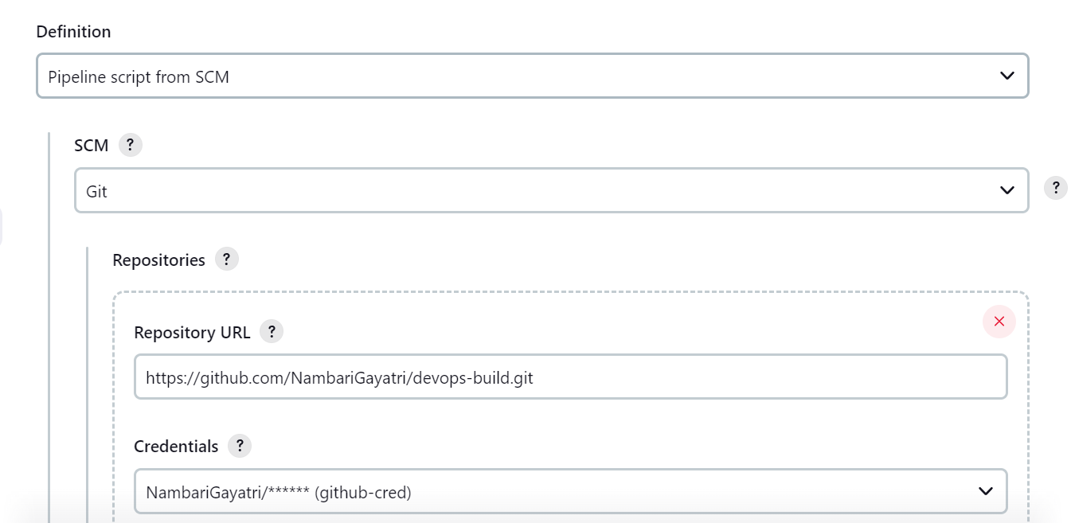

Stage View:

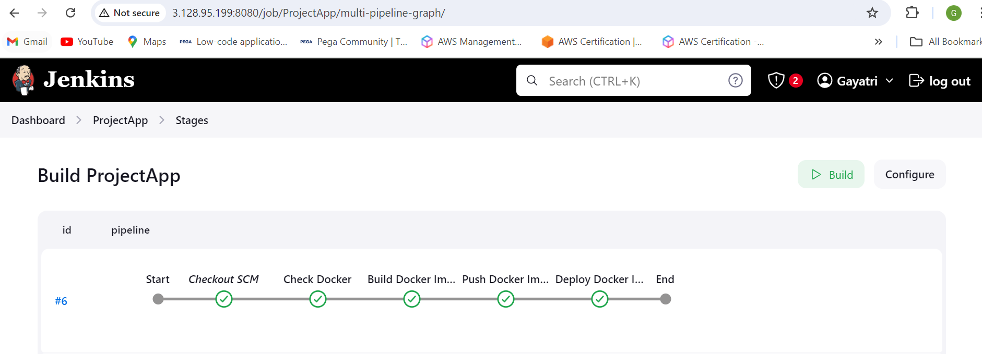

**DockerHub**

Created two repos called ‘dev’ and ‘prod’, where dev is public and prod is private.

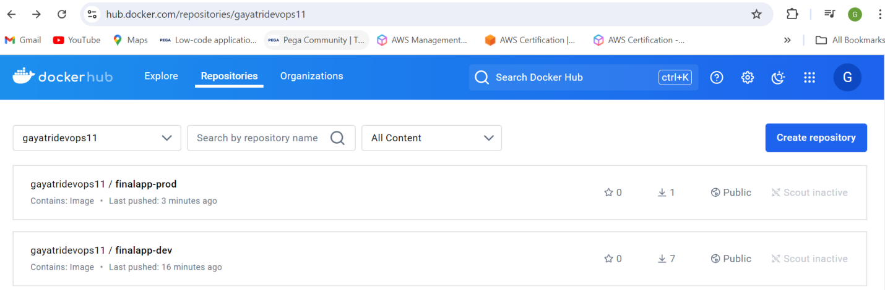

Dev Repo:

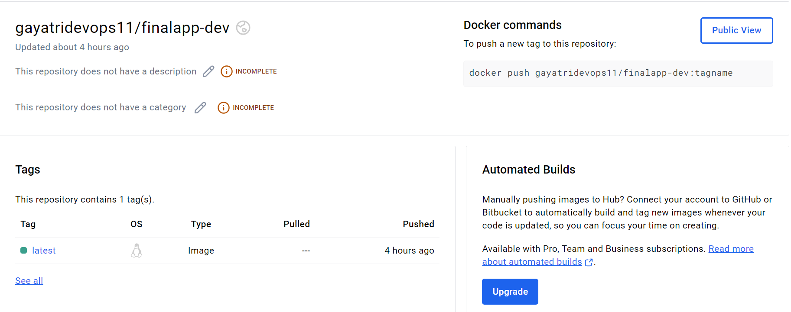

Prod Repo:

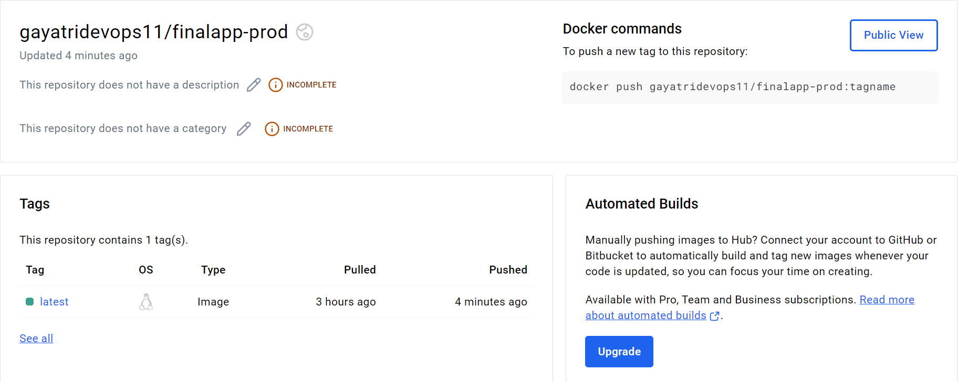

Deployed Site:

Deployed site URL: http://ec2-3-128-95-199.us-east-2.compute.amazonaws.com/

